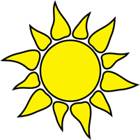
HEAT-RELATED ILLNESSES

Heat Stroke | Heat Exhaustion
Hot, red, dry skin | Pale, cool, clammy skin
Altered mental status | Irritable
Usually no sweating | Excessive sweating
Headache, nausea or vomiting | Headache, nausea or vomiting
Loss of consciousness | Dizziness
CALL 911 IMMEDIATELY!  COOL DOWN PERSON ANY WAY YOU CAN. | Cool down person. Move to shaded area. Give cool drinks. Call for medical assistance.

This material was produced under grant number SH05051SH8 from the Occupational Safety and Health Administration, U.S. Department of Labor. It does not necessarily reflect the views or policies of the U.S. Department of Labor, nor does mention of trade names, commercial products, or organizations imply endorsement by the U.S. Government.

