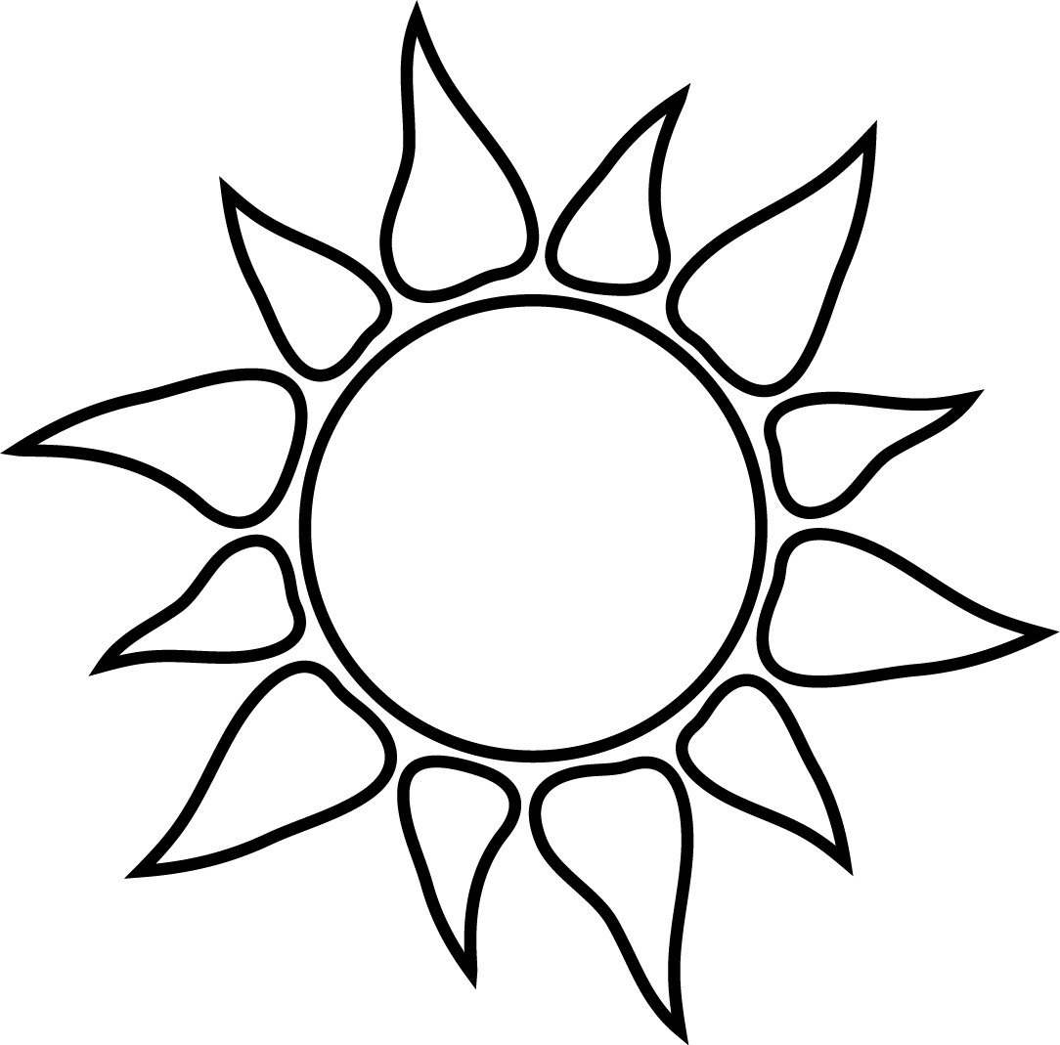
Lotería
Learn about heat-related illnesses through a traditional game of chance, similar to bingo but using pictures instead of numbers.

Materials Supplied:
- 6 Loteria playing boards
- 27 Lotería playing cards

Materials Needed:
- Tokens such as coins – 9 per player

Preparation:
- Print out the six playing boards and the three pages of playing cards.
- For repeated use, print the playing boards and playing cards on card stock paper or have them laminated.
- Each sheet of playing cards contains nine individual playing cards. Cut the sheets along the black lines, giving nine individual cards per sheet for a total of 27 individual playing cards.

Playing the Game:
- You can play multiple versions of the game. Decide if you are going to play three across, four corners or coverall.
- Give each player a playing board and tokens. You will need 9 tokens per player if you are playing coverall.
- Shuffle the playing cards.
- Read the description on the playing card, not the title. For example, the playing card for Heat Stroke has “Heat Stroke” in the white title box and the definition: “A medical emergency with a dramatic rise in body temperature” given below the title box.
- Each player must identify the picture or phrase on their playing card that corresponds to the description and cover the space with the token.
- If the player has the correct number of spaces covered (3, 4 or all 9 for coverall), they should call out Lotería.
- Check to see if the player who called out Lotería correctly identified the pictures and phrases. If so, they are the winner.
- You can continue the game for more winners or begin again.
- If the player claims Lotería and they are incorrect, they are disqualified from that round.

Heat Exhaustion | Light-Colored Clothing  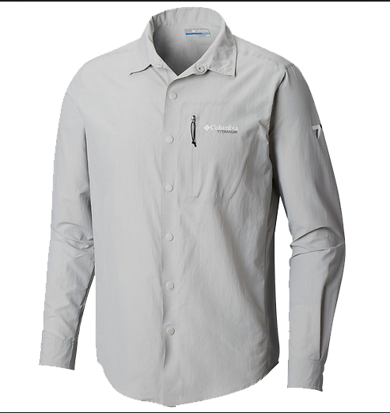  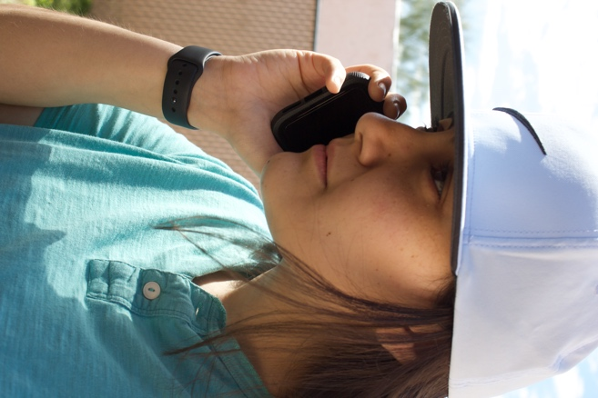 | Call 911
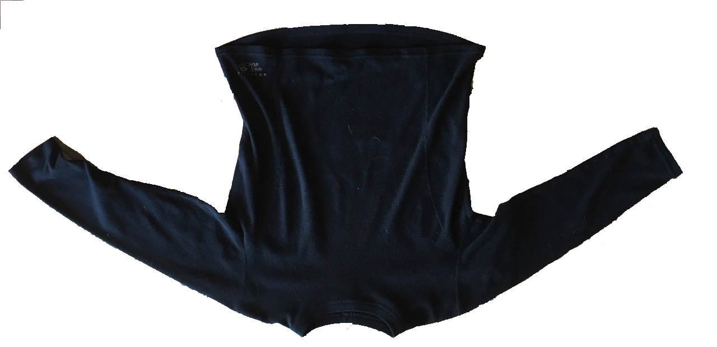  Dark-Colored Clothing | Direct Sun  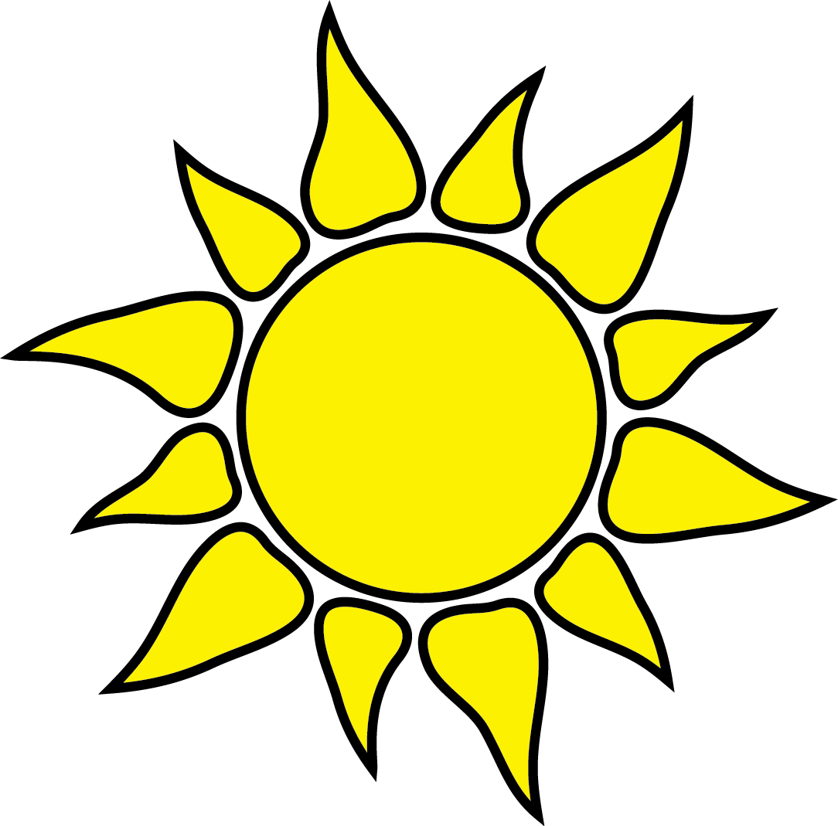 | Wear a Hat
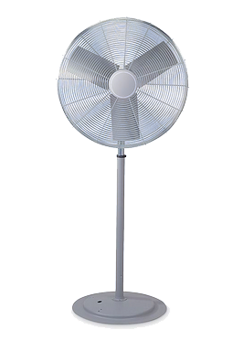  Fan | 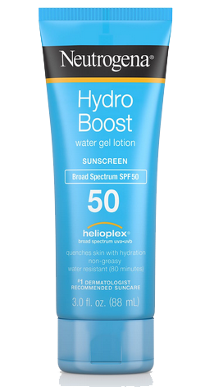  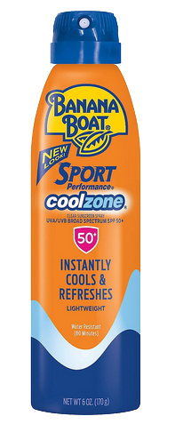  Sunscreen | 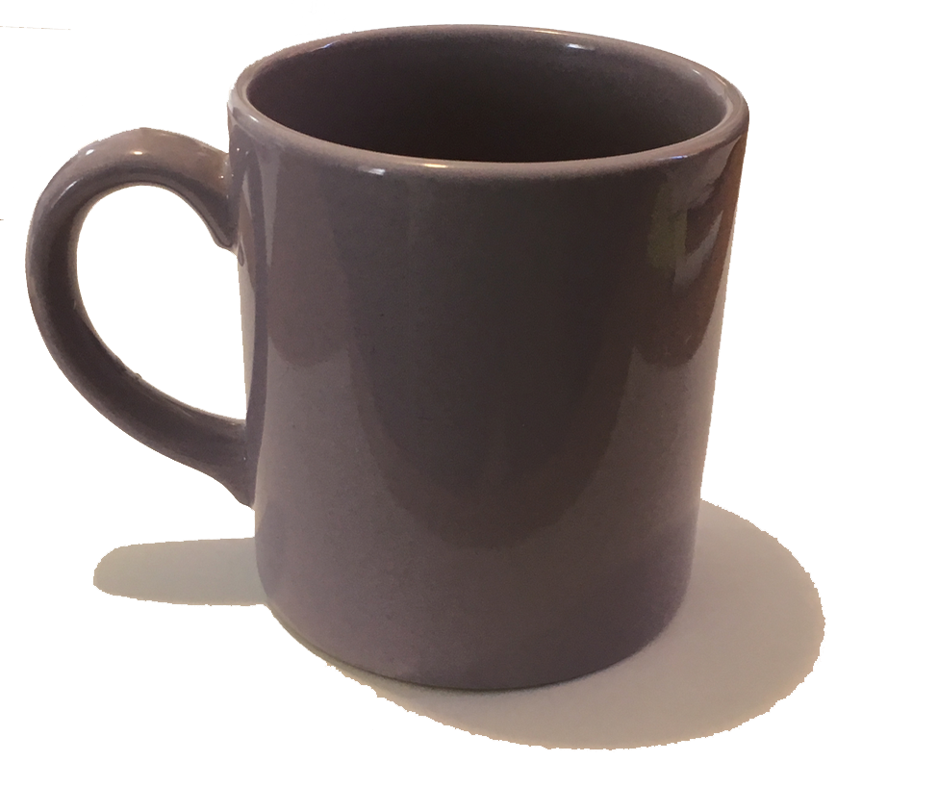  Caffeine

Light-Colored Clothing | 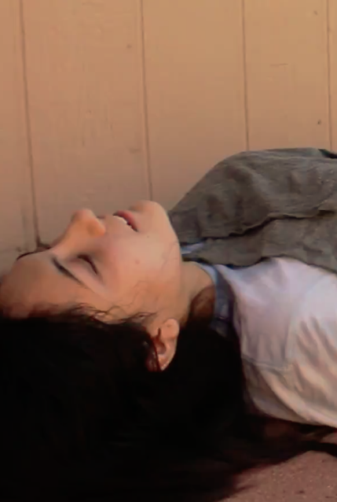  Cold Compresses | Direct Sun
Take Frequent Breaks | Hyponatremia | 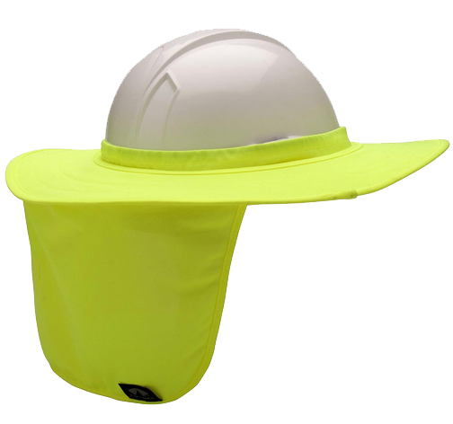  Hard Hat with Sun Shade
 | 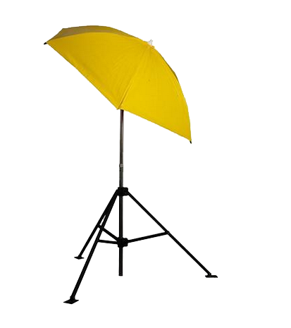  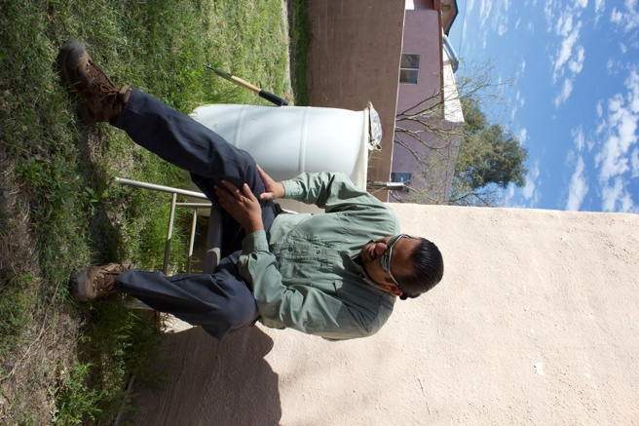  Industrial Umbrella  Heat Stroke | Heat Cramps
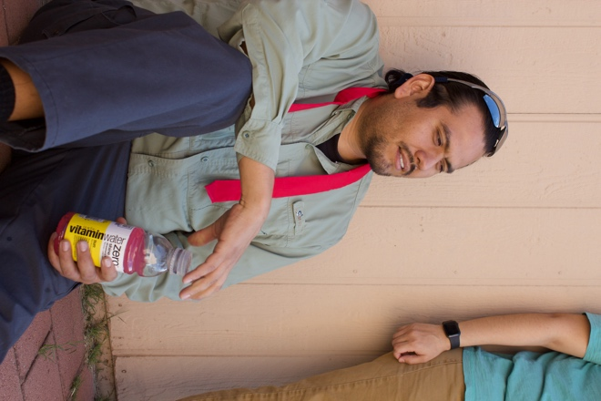
Sunglasses  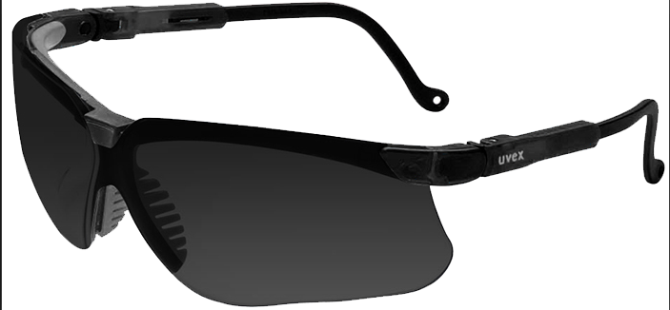 | Call 911 | Fan
Heat Exhaustion | Dark-Colored Clothing | Acclimatize
Heat Cramps | Hard Hat with Sun Shade | 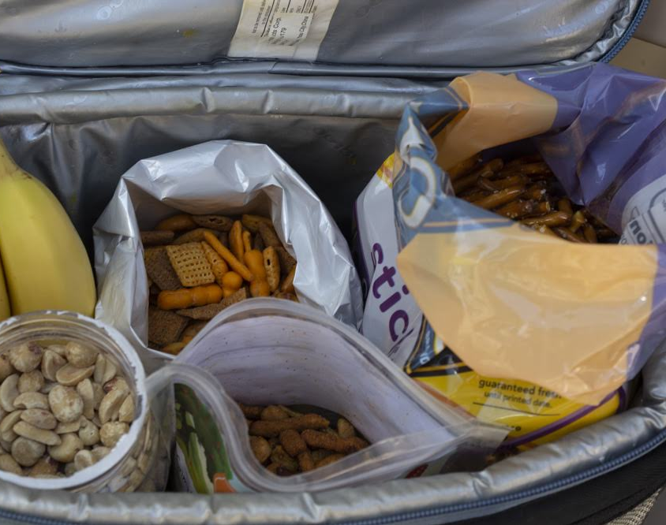  Salty Snacks
High Temperatures  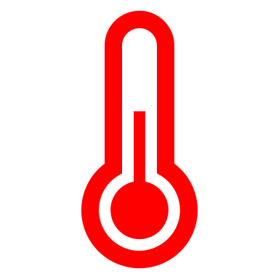 | Sunscreen | Heat Stroke
Drink Plenty of Fluids | Water Cooler | 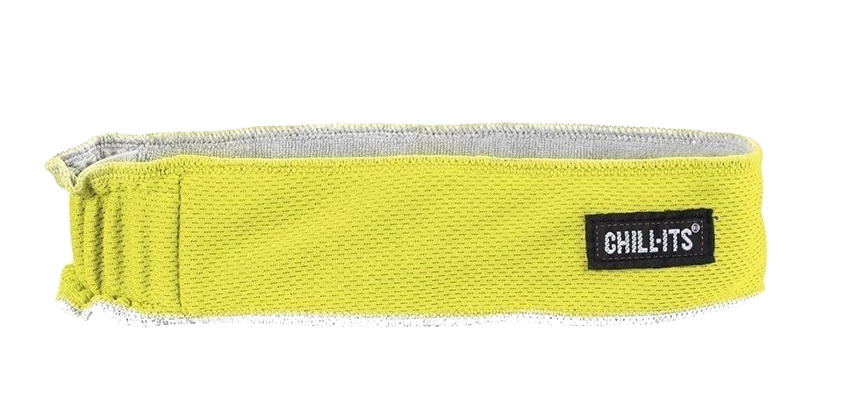  Cooling Band
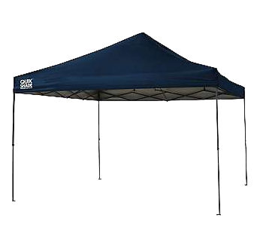 | Salty Snacks  Shade Structure | 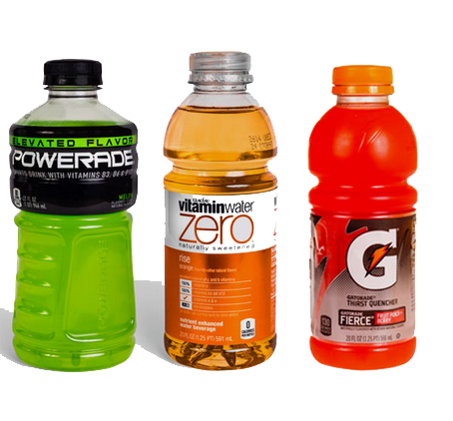  Sports Drinks
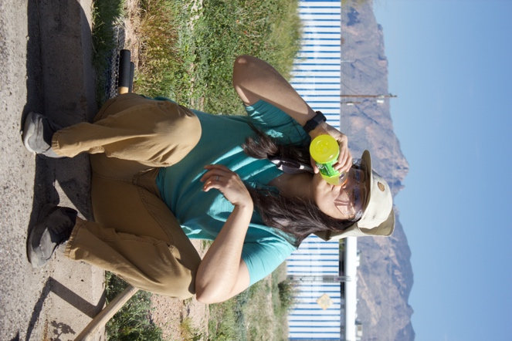
Ball Cap  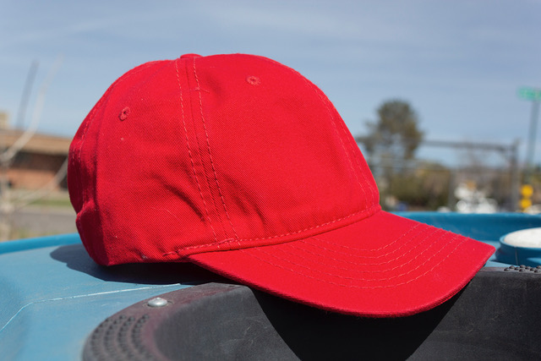 | Take Frequent Breaks | Wear a Hat
Sports Drinks | Cold Compresses | Drink Plenty of Fluids
Cooling Band | Water Cooler | Shade Structure

Sunglasses | Water Cooler | Cooling Safety Vest  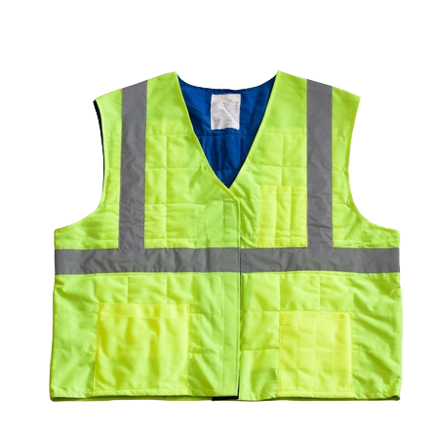
Wear a Hat | Shade Structure | Direct Sun
Industrial Umbrella | Heat Stroke | Sports Drinks

Becoming more tolerant of heat by gradually increasing time worked in hot areas over a period of 7 to 14 days.  Acclimatize | These hats have a wide front brim but do not protect the neck and ears from the sun.  Ball Cap | This substance is often found in coffee, teas and sodas and may increase your risk for dehydration when working in extreme heat.  Caffeine
Heat stroke is a medical emergency and you should immediately call this number.  Cooling Band  Call 911 | Workers suffering from heat stroke can be cooled with these placed on the head, neck, armpits and groin.  Cold Compresses | Wet this and place it around your neck to help you stay cool.  Cooling Band
This type of vest uses evaporative cooling to keep you cool on the job.  Cooling Safety Vest | Working in this increases your risk of heat-related illnesses especially when it is tight-fitting.  Dark-Colored Clothing | Working in this rather than in the shade increases your risk of heat-related illnesses.  Direct Sun

You should do this when working in heat to avoid dehydration.  Drink Plenty of Fluids | This can be used to circulate air and help keep workers cool especially indoors.  Fan | Wear this when you need to protect their head from injury and are working in the direct sun.  Hard Hat with Sun Shade
Muscle cramps or spasms that can be caused by the loss of electrolytes from heavy sweating.  Heat Exhaustion  Heat Cramps  Cooling Band  Loss of electrolytes in sweat | A heat-related illness which may include heavy sweating and pale, cool and clammy skin. | A medical emergency with a dramatic rise in body temperature that can be fatal.  Heat Stroke
Working in these along with high humidity increases your risk of heat-related illnesses, especially if you are not acclimatized.  High Temperatures | A heat-related illness caused by drinking too much water and losing too much salt through sweating.  Hyponatremia | This is a portable lightweight method of providing shade usually for one person.  Industrial Umbrella

This is often the best type of clothing to wear when working in heat especially if it is loose-fitting and allows air movement.  Light-Colored Clothing | Eat these to help replace the sodium lost from sweating.  Salty Snacks | When no shade is available, this structure can provide shade for you and your coworkers.  Shade Structure
Drink these when working in hot areas to help replace electrolytes lost from sweating.  Cooling Band  Sports Drinks | Wear these to protect your eyes from the sun’s ultraviolet rays.  Sunglasses | Apply this regularly to avoid sunburn.  Sunscreen
When working in a hot area you should do this frequently preferably in the shade or a cool area.  Take Frequent Breaks | Having one of these at your worksite is a good way to provide cool water to employees.  Water Cooler | Do this to keep direct sun off your head and help prevent heat-related illnesses.  Wear a Hat

