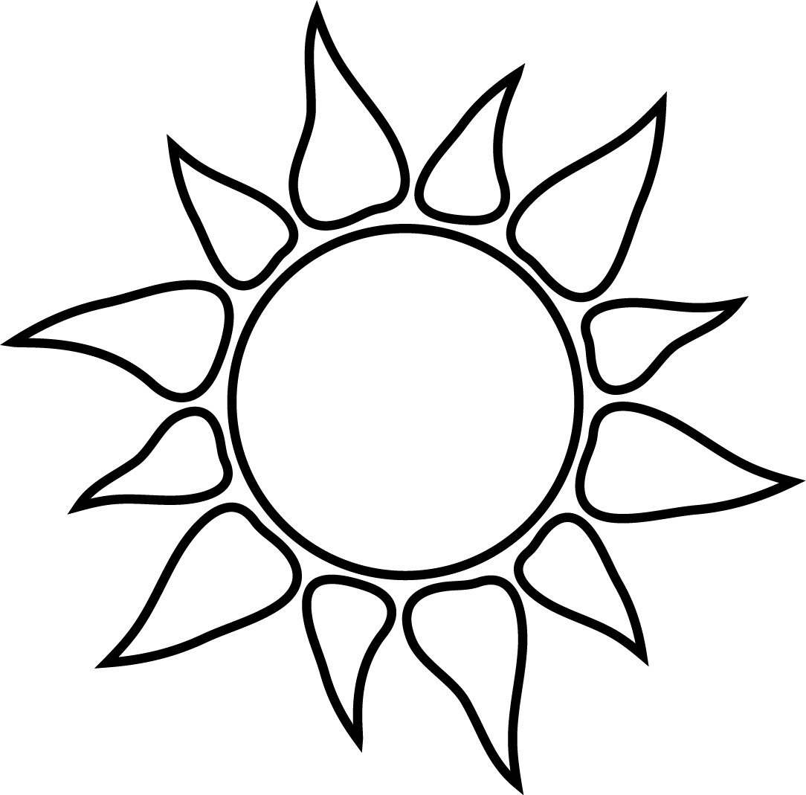
CROSSWORD PUZZLE
Test your knowledge about heat-related illnesses with this crossword puzzle. Read the clues below and fill in the best answer.

Down:
1. This is a medical emergency that may result in death. Signs and symptoms may include confusion; loss of consciousness; hot, dry, red skin, seizures and a very high body temperature.
2. When you are taking a break outside, you should rest in this.
3. Our body’s natural cooling mechanism.
4. Heat-related illnesses not only affect workers outdoors but can also affect workers in hot areas __________.
6. Some of these can lower your heat tolerance, both prescription and over-the-counter.
7. Signs and symptoms of this heat-related illness include heavy sweating; headache; nausea; dizziness; elevated body temperature; irritability; weakness and pale, cool, clammy skin.
10. When working in a hot environment, you should take __________ breaks.
12. Often occurs in skin that is persistently wet from sweating and looks like a red cluster of pimples or small blisters.
17. When working outdoors in the direct sun, you should wear one of these with a wide brim and a neck shade.
18. Especially indoors this will circulate air and cool workers.

Across:
5. You can become __________ while working in a hot environment when you lose more fluid from sweating than you are taking in.
8. The primary sign of this heat-related illness is fainting, usually for a short duration.
9. You may develop this heat-related illnesses when you drink large quantities of water and lose sodium from significant amounts of sweating.
11. Consumption of this type of beverage prior to or during work in a hot environment may lower your heat tolerance and increase your risk of a heat-related illness.
13. Often in heat stroke, the patient’s face will be this color.
14. We need this liquid to keep us hydrated. It is vital for life.
15. Workers can build up their __________ to heat after daily heat exposure for 7 to 14 days.
16. Working in hot and __________ conditions increases your risk to heat-related illnesses.
19. You may have this heat-related illness when your muscles spasm or cramp when working in a hot environment. These can be a sign of heat exhaustion.
20. Workers should be trained on how to prevent, recognize and __________ heat-related illness.
21. When working outside in a hot environment, you should have a cup of cool water every 15 to 20 __________.

CROSSWORD PUZZLE

 |  |  |  |  |  |  |  |  |  |  |  | 2 |  | 3
 |  |  |  |  |  |  | 1
 |  |  |  | 4 | 5 |  |  |  |  |  |  |  |  |  |  |  |  |  |  |  | 6
 |  |  |  |  |  |  |  |  | 7 | 8
9
 |  |  |  |  |  |  |  |  |  |  |  |  |  |  | 12
 |  | 10 |  |  |  |  |  |  |  | 11
13 |  |  |  |  |  |  | 14 |  |  |  |  |  |  | 15
 |  |  |  |  |  |  |  |  |  |  |  | 18
16 |  |  |  |  |  | 17
 |  |  |  |  | 19
 | 20
 |  |  |  |  |  | 21

CROSSWORD PUZZLE
Answer Key

 |  |  |  |  |  |  |  |  |  |  |  | 2 |  | 3
 |  |  |  |  |  |  | 1 |  |  |  |  | S |  | S
 |  |  |  |  |  |  | H |  |  |  |  | H |  | W
 |  |  |  | 4 | 5 | D | E | H | Y | D | R | A | T | E | D |  |  |  |  |  | 6
 |  |  |  | I |  |  | A |  |  |  |  | D |  | A |  |  |  |  |  |  | M
 |  |  |  | N |  |  | T |  | 7 | 8 | H | E | A | T | S | Y | N | C | O | P | E
 |  |  |  | D |  |  | S |  | H |  |  |  |  | I |  |  |  |  |  |  | D
9 | H | Y | P | O | N | A | T | R | E | M | I | A |  | N |  |  |  |  |  |  | I
 |  |  |  | O |  |  | R |  | A |  |  |  |  | G |  |  |  |  |  |  | C
 |  |  |  | R |  |  | O |  | T |  |  |  |  |  | 12 |  |  |  |  |  | A
 |  | 10 |  | S |  |  | K |  | E | 11 | A | L | C | O | H | O | L |  |  |  | T
 |  | F |  |  |  |  | E |  | X |  |  |  |  |  | E |  |  |  |  |  | I
 |  | R |  |  |  |  |  |  | H |  |  |  |  |  | A |  |  |  |  |  | O
13 | R | E | D |  |  |  | 14 | W | A | T | E | R |  | 15 | T | O | L | E | R | A | N | C | E
 |  | Q |  |  |  |  |  |  | U |  |  | 18 |  |  | R |  |  |  |  |  | S
16 | H | U | M | I | D | 17 |  |  | S |  |  | F |  |  | A
 |  | E |  |  | 19 | H | E | A | T | C | R | A | M | P | S
 |  | N |  |  |  | A |  |  | I |  |  | N |  |  | H
 | 20 | T | R | E | A | T |  |  | O
 |  |  |  |  |  | 21 | M | I | N | U | T | E | S

