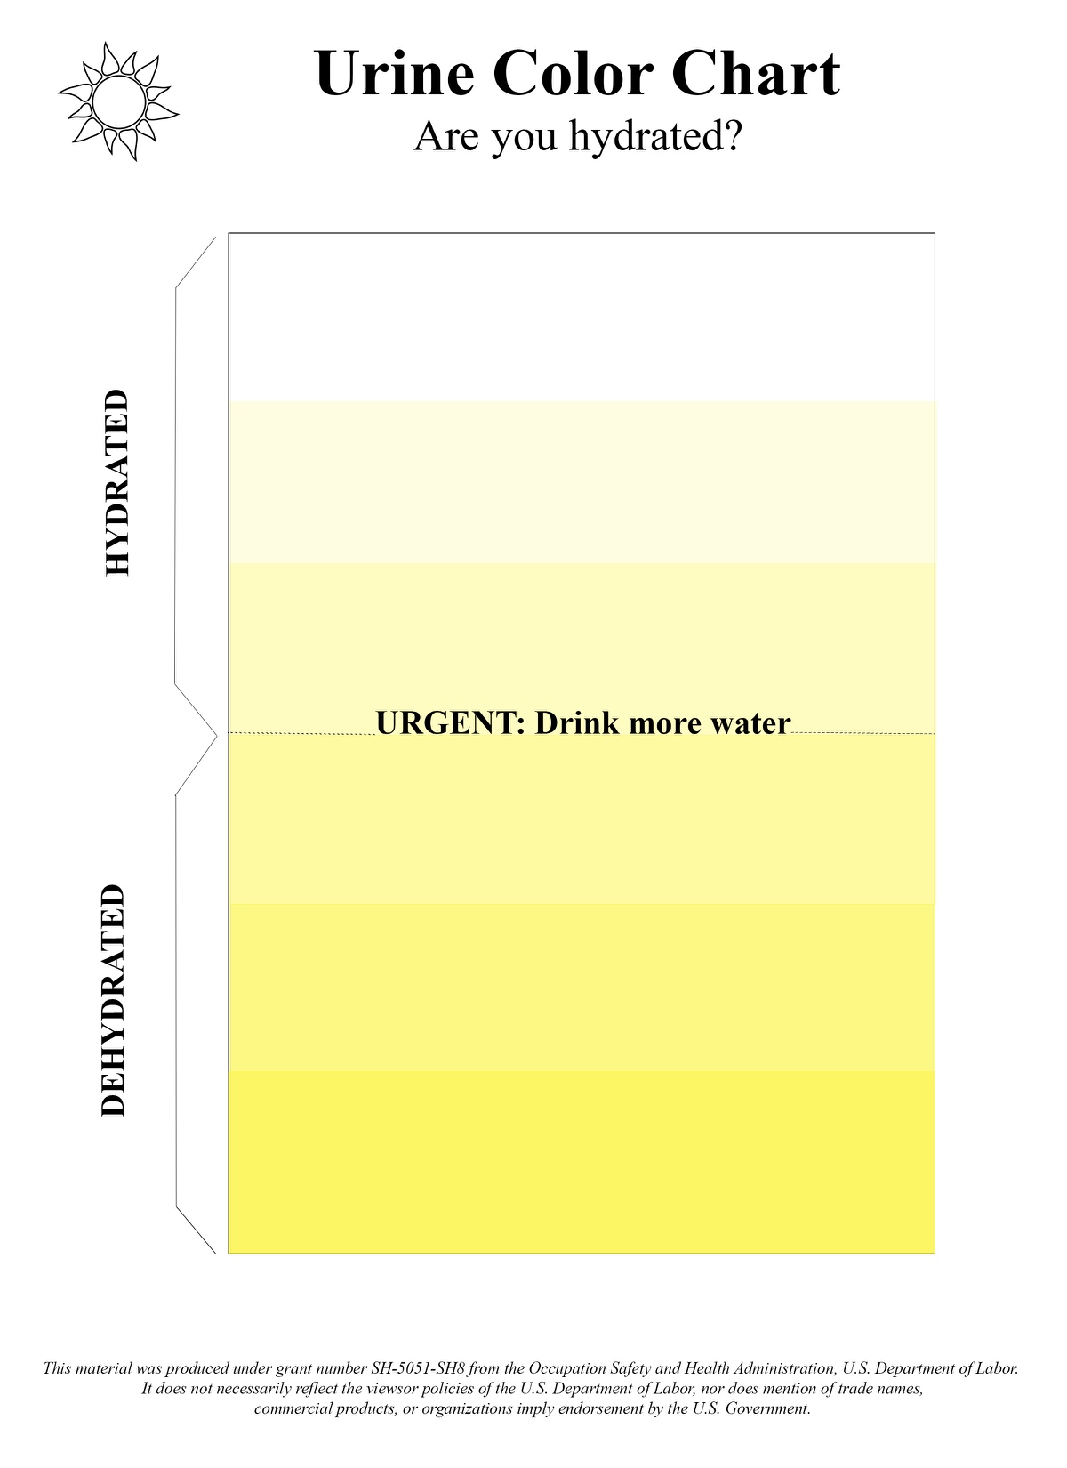

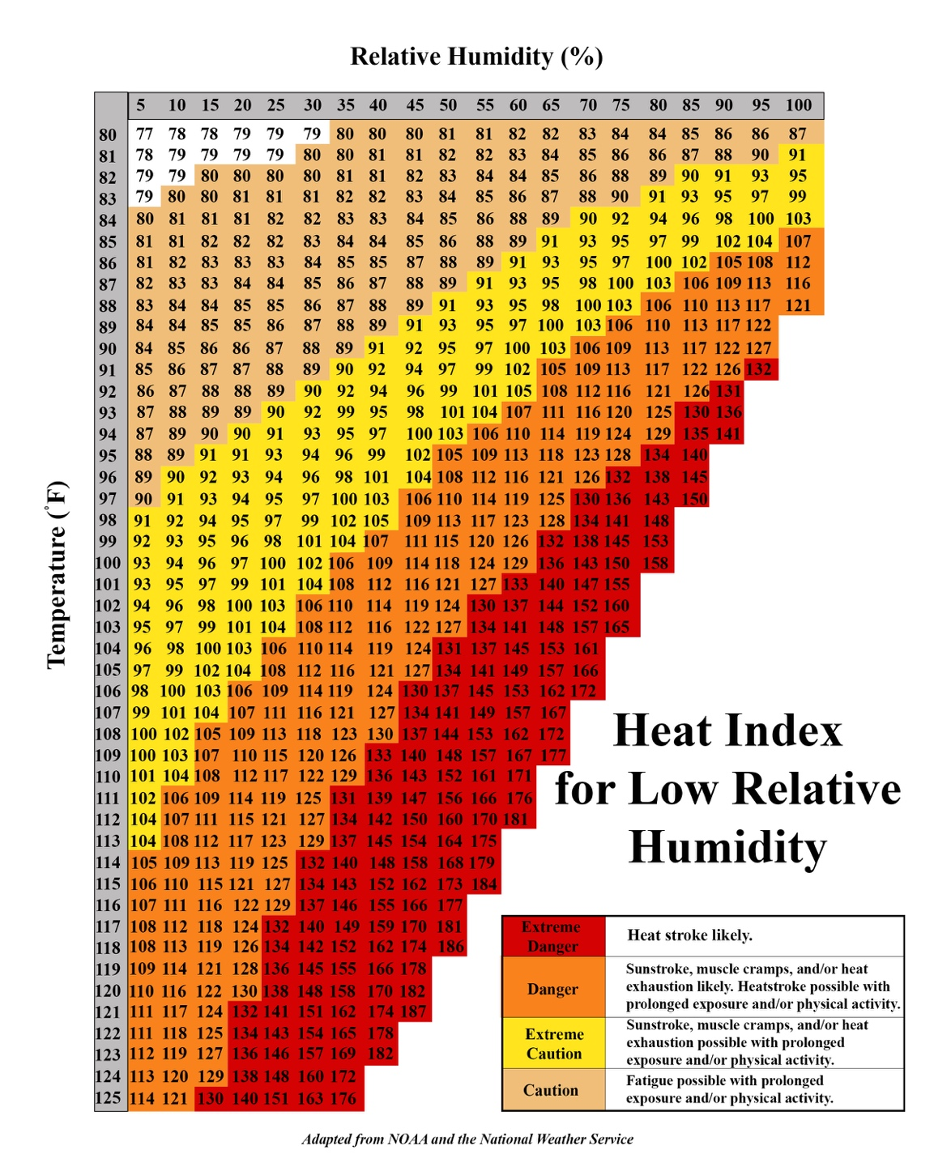

*This material was produced under grant number SH05051SH8 from the Occupational Safety and Health Administration, U.S. Department of Labor. It does not necessarily reflect the views or policies of the U.S. Department of Labor, nor does mention of trade names, commercial products, or organizations imply endorsement by the U.S. Government.*

*This material was produced under grant number SH05051SH8 from the Occupational Safety and Health Administration, U.S. Department of Labor. It does not necessarily reflect the views or policies of the U.S. Department of Labor, nor does mention of trade names, commercial products, or organizations imply endorsement by the U.S. Government.*



*This material was produced under grant number SH05051SH8 from the Occupational Safety and Health Administration, U.S. Department of Labor. It does not necessarily reflect the views or policies of the U.S. Department of Labor, nor does mention of trade names, commercial products, or organizations imply endorsement by the U.S. Government.*

*This material was produced under grant number SH05051SH8 from the Occupational Safety and Health Administration, U.S. Department of Labor. It does not necessarily reflect the views or policies of the U.S. Department of Labor, nor does mention of trade names, commercial products, or organizations imply endorsement by the U.S. Government.*